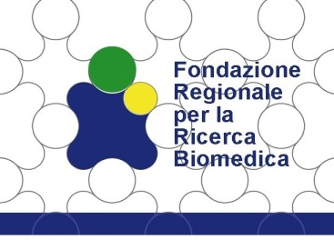

“BANDO PROGETTI DI RETE - II EDITION”

ANNUAL SCIENTIFIC REPORT TEMPLATE

VERSIONE | DATA DI PUBBLICAZIONE | MODIFICHE
0 | Dicembre 2020 | Emissione iniziale

- GENERAL PROJECT INFORMATION
- Project number:
- Project acronym:
- Project title:
- Start date:
- Project duration (in months):
- Name of the project’s coordinator:
- Organization of the project's coordinator:
- Period covered by the report:
IMPORTANT: you are asked to report results, events and publications achieved from the very beginning of the project! Pleas, also insert the results already reported for Year 1.

- WORK PROGRESS AND ACHIEVEMENTS
Please complete the table below by reporting all the deliverables indicated in the “Section II.3 - List of Deliverables per months” of the project proposals, specifying the reference WP, the timing and indicating whether the specific action is accomplished or not.
Objectives/actions/tasks/deliverables | WP | Timing  (month) | Completed
 |  |  | YES | NO
D1. “Title”

For each accomplished objective/action/task/deliverable, please explain:
- Partner involved
- Obtained results (Max 1/2 page, plus figures and legends)
- Pitfalls and caveats and how they have been overcome, or possible solutions to overcome them (Max 1/2 page)
Dissemination events:
- Describe any participation to dissemination events (workshops, congresses, non-scientific events for the lay public, etc.)
List them, indicating title of the event, date, role (speaker, participant, etc.). Where applicable, please copy and paste the abstract of the dissemination event attended (No page limit)

Publications:
- List all publications in the context of the project funded by FRRB, including any submitted papers.
- Please report all the publications also in the excel file “Publications” specifying:
- Title
- Journal and related Impact factor
- Partners involved
- Members of the team supported by FRRB among the authors
- In case of other source of funding declared in the acknowledgments, specify very briefly which aspects of the published work have been developed with the FRRB funding or with other funds of the PIs
- In case of accepted papers, please provide the related PDF file in the section “other documents” of BoL.
- Explanation oN the use of resources
Please provide an explanation of any major direct costs incurred by each beneficiary in this reporting period (personnel costs, purchase of important equipment, travel costs, large consumable items, etc.) and describe any relevant variation compared to the initial approved financial plan.
(Max 1 page).
- Lay SUmmary of the project
Please provide a summary to conveying the rationale and main achievements of the project to lay public, highlighting the impact on the Regional Healthcare System. It has to be written in plain Italian and explaining any technical terms that need to be included (Max 2,000 characters including spaces).

