NAME OF THE PROGRAMME
European Joint Programme on Rare Diseases (EJP RD) (JTC 2022)

NAME OF THE JOINT CALL
Joint Transnational Call 2022: "Development of new analytic tools and pathways to accelerate diagnosis and diagnostic monitoring of rare diseases”

Fondazione Regionale per la Ricerca Biomedica (FRRB)
Pre-eligibility form to be filled out by each Partner requesting funding to FRRB.

Before filling out the form, please read the “Guidelines for Applicants” (available here: https://www.ejprarediseases.org/our-actions-and-services/funding-opportunities/calls/)
Only Institutions/ Principal Investigators (PIs) based in Lombardy can apply for funding to FRRB.
All PIs applying to the EJP Rare Diseases JTC 2022 must submit this form to FRRB, duly completed and signed, at least 10 working days before the pre-proposal submission deadline.
Please send it (in PDF) to: bandi@frrb.it specifying in the subject “EJP RD JTC 2022-Pre-eligibility_ ACRONYM OF THE PROJECT”.
FRRB will provide feedback on the “Pre-eligibility check form” ONLY in case of major issues or non-eligibility. PIs who submit a proposal without sending the “Pre-eligibility check form” to FRRB in advance will be automatically excluded.

- Project title, Coordinator and Partners (information currently available)

Project Title
Project Acronym
Project Coordinator
Project Coordinator’s Institution
Project Coordinator’s Country
Other Partners (add lines as relevant). Please include your institution, if it is not the coordinator.
No. | Country | Institution |  | Type of Entity  H=Health care provider, IRCCS or ASST; A=Academia; RO: Research Organisation; I/SME=Industry or SME; PO: Patient Organisation

- Lombardy Beneficiary Institution
Please note: if two Lombardy entities/PIs are partners in the same project, FRRB requests a separate form per entity/PI.

Name of the Institution
Address of the Institution (“sede legale”)
Legal Representative
Phone
E-mail
Type of entity  (Tick as appropriate) | ☐ Universities  ☐ Research Institutes  ☐ Public Health Care Providers (ASST)  ☐ Public or Private Italian IRCCS

- Lombardy Principal Investigator (PI)

Name and Surname
Role in the organisation
Phone
E-mail
Institution where the project activities will be implemented
Address of the Institution (“Sede Operativa”) | If different from the address above
Role of the PI unit in the
project (max. 500 characters)
Approximate requested budget (€) for the Lombardy beneficiary

- Other Lombardy Beneficiary in the same Project Consortium (if there is no other Lombardy beneficiary in the same project, please ignore this section)

IMPORTANT INFORMATION
To request funding from FRRB, it is COMPULSORY that at least one IRCCS (public or private) or ASST based in Lombardy is Partner in the project proposal. Other types of organisations (among those eligible, according to the guidelines) are eligible ONLY in partnership with one of them. The maximum amount granted by FRRB is € 500,000 per project and there can be maximum two Lombardy partners per project.
FRRB requires one form per Lombardy Beneficiary, also for Partners in the same Project Consortium.
Please report in the table below the main details on the other Lombardy beneficiary participating in the project. The beneficiary identified in the table below is required to submit its pre-eligibility check form. FRRB will match the forms of the Lombardy Beneficiaries collaborating in the same project.

Please report in the table below the main details on the other Lombardy beneficiary participating in the project. The beneficiary identified in the table below is required to submit its pre-eligibility check form. FRRB will match the forms of the Lombardy Beneficiaries collaborating in the same project.
Is there any other Lombardy Beneficiary? |  | YES ☐ | NO ☐
If YES:
Name of the Institution
Name of the PI
Address
E-mail

Privacy policy, available at the following link: https://www.frrb.it/it/ejp-jtc-2022
☐ I confirm I have read and agree to FRRB Privacy policy available on the FRRB EJP RD JTC 2022 webpage

DATE: Signature of the Principal Investigator
………………….. ……………………………………………………

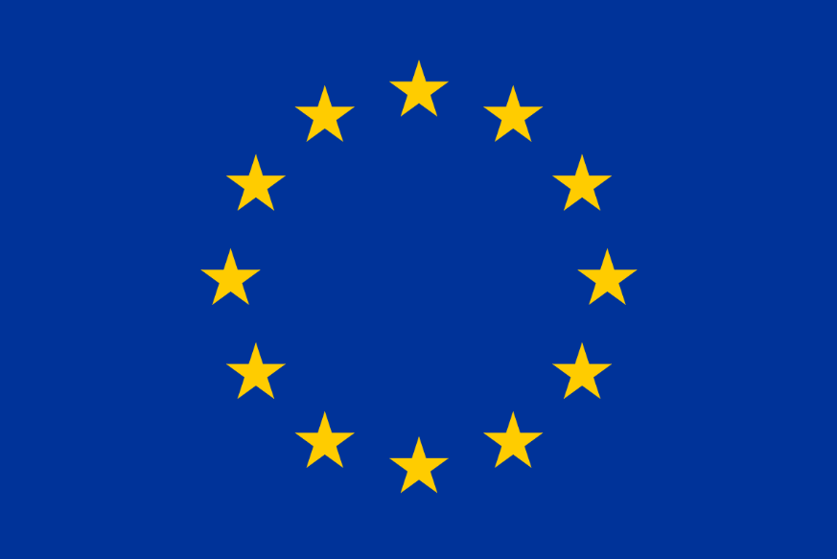
This project has received funding from the European Union’s Horizon 2020 research and innovation programme under grant agreement No 825575

We request one form per Partner also for Partners in the same project consortium
FRRB acknowledges that minor changes can occur before the final submission of the project. Please fill out this form with the most up-to-date information.

